“Top ten messages” of Laudato Si’  Based on a video presentation of Pope Francis’ teaching, by Fr. James Martin S.J.  1. Spiritual perspective. Pope Francis’ encyclical (open letter on church teaching) provides an overview of the environmental crisis from a religious point of view. Previously the dialogue had been framed in political, scientific and economic language. Now the language of faith decisively enters the discussion.  2. Effects on the poor. The disproportionate effect of environmental change on the poor is strongly highlighted in almost every page of the document, with many examples.  3. Critique of the “technocratic mindset”. From this perspective, technological development is seen as the key to human existence with an unthinking reliance on market forces: technological advances are embraced before thinking through how they will affect our world. Christian spirituality in contrast offers a growth marked by moderation and a capacity to be happy with little.  4. Authoritative teaching. Against those who suggest that a papal encyclical on the environment has no real authority, Pope Francis explicitly states that Laudato Si’ is now added to the Church’s body of social teaching, continuing a long tradition.  5. Christian / Biblical roots. Discussions about ecology can be grounded in the Bible and Church tradition. Chapter 2 introduces the “Gospel of Creation” and shows how the call to care for creation extends back as far as the Book of Genesis where mankind was called to “till and keep the Earth” – but sadly we have done too much tilling and not enough keeping.  6. Everything is connected. Laudato Si’ offers a systematic approach to the problem. Pope Francis links us all to creation: we are part of nature, included in it and in constant interaction with it. But our decisions have an inevitable effect on it. The blind pursuit of money that sets aside the interests of the marginalised and poor and the ruination of the planet are connected.  7. Embrace of science. The Pope does not attempt to prove anything about climate change. Rather the encyclical accepts the best scientific research of today and builds on it. It draws on both church teaching and contemporary scientific findings from all disciplines to help modern-day people reflect on important questions.  8. Selfishness and indifference critiqued. Pope Francis critiques those who ignore climate change and especially its effect on the poor. Why are so many of the wealthy turning away from the poor? Not only because some view themselves as more worthy than others, but also because frequently decision-makers are removed from the poor with no real physical connection to their brothers and sisters. Selfishness also leads to the evaporation of the notion of the common good.  9. Global dialogue and solidarity. Pope Francis draws on the experiences of people from all around the world. The Pope calls into dialogue all people about our common home.  10. Ecological conversion. This encyclical is addressed to everybody on the planet and calls for a new way of looking at things. We face an urgent crisis where the earth begins more and more to look like an “immense pile of filth”. However the document is hopeful: because God is with us, all of us can strive to change course: we can move towards an ecological conversion, listening to the cry of the poor and the cry of the earth. In religious language, the Pope is calling for conversion.  To watch the video (4min) go to https://www.youtube.com/watch?v=a_lqFTYLc_4 | CHURCHES TOGETHER  IN CHAPEL ALLERTON AND MEANWOOD  Laudato Si’ -Pope Francis’ teaching on  CLIMATE AND THE ENVIRONMENT  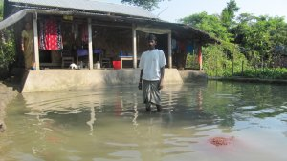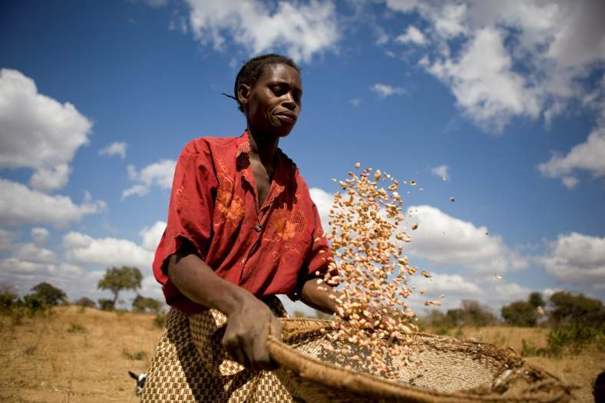  I will………  “For all our limitations, gestures of generosity, solidarity and care  cannot but well up within us, since we were made for love”(para 58)  A post-it note to myself…some suggestions inside

What can I do?
…switch to a green energy supplier
…try to be optimistic and realise more that influence must be public and political
…contact my pension providers about investments in fossil fuels
…put quotes from Laudato Si’ in parish bulletins and newssheets as reminders
…support locally produced food
…talk to church groups about Laudato Si’
…buy Fairtrade in my weekly shop

…consider using solar panels
…wear warm clothing and reduce central heating
…sign up to CAFOD
…turn off more unnecessary lights at home

Download and read Laudato Si’
…avoid running taps wastefully.
…contact my MP
- has s/he read Laudato Si’?

As a parish, discuss how we could work together to reduce food wastage
Distribute literature to friends, church members etc
…share this information with the young
...walk more,
use car less..
live more simply
…write an email to the Minister for Energy
…learn more about what is meant by sustainability and renewable energy
…use leftover food in another meal

…discuss climate and poverty issues with my family

…pray for world leaders and decision makers
…use the tumble drier less often
….join a Global Justice Now campaign
…ask parish about using green energy supplier-even if more expensive
…become more informed by reading and sharing relevant newspaper articles on the internet and social media

…have 3 days a week meat -free and car-free!
…pray for the poor of our planet
….write to supermarkets about food waste and support campaigns on this subject

